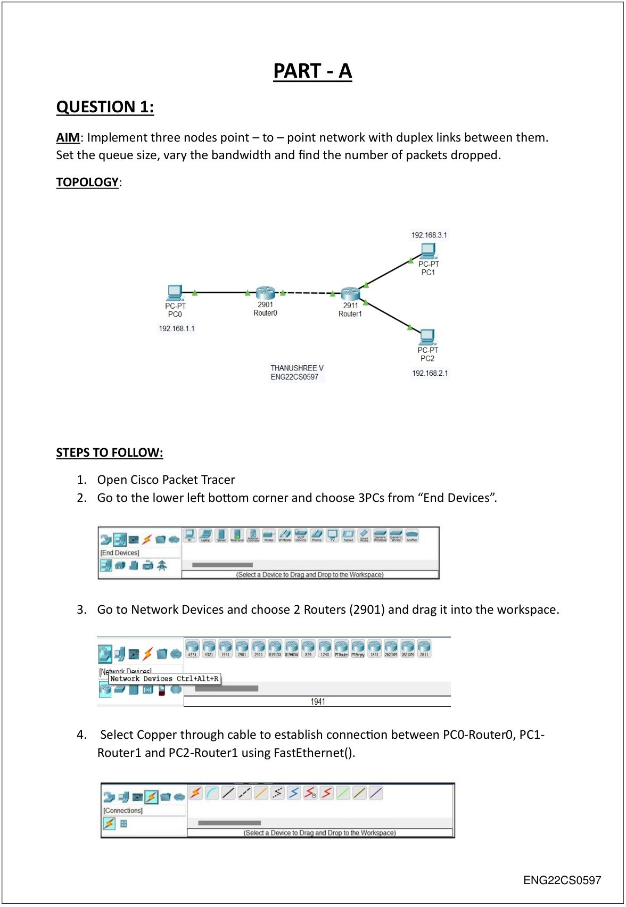

ENG22CS0169

SYED FUZAIL ENG22CS0476

Scanned with ACE Scanner

ENG22CS0476

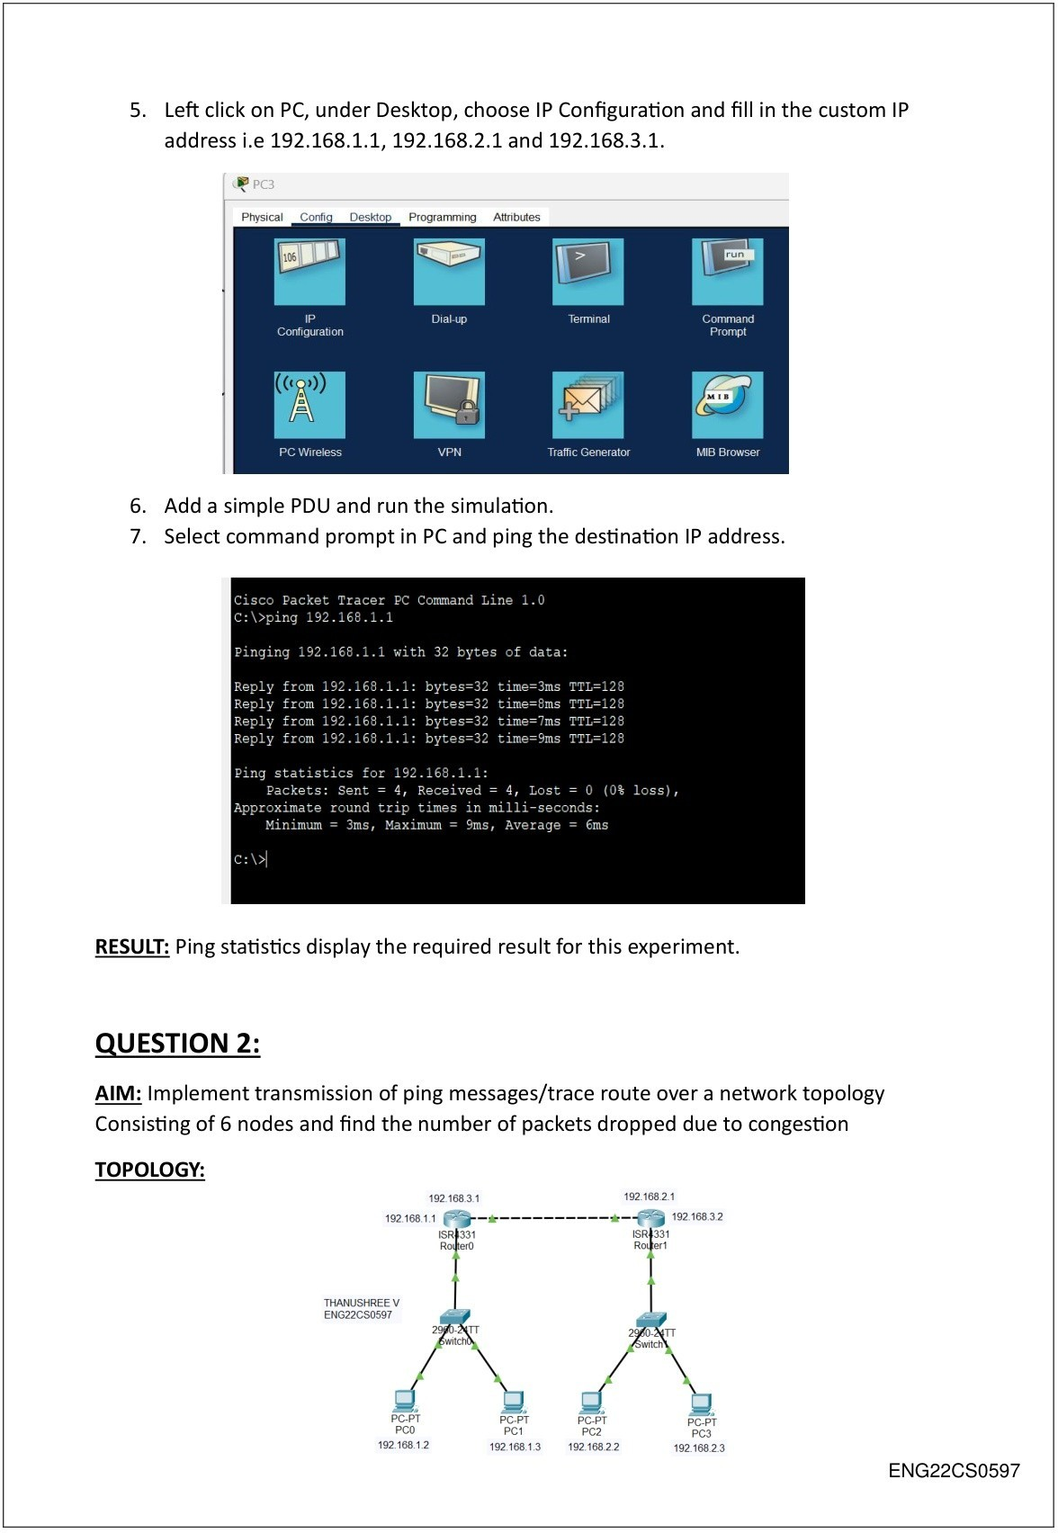

ENG22CS0169

SYED FUZAIL ENG22CS0476

Scanned with ACE Scanner

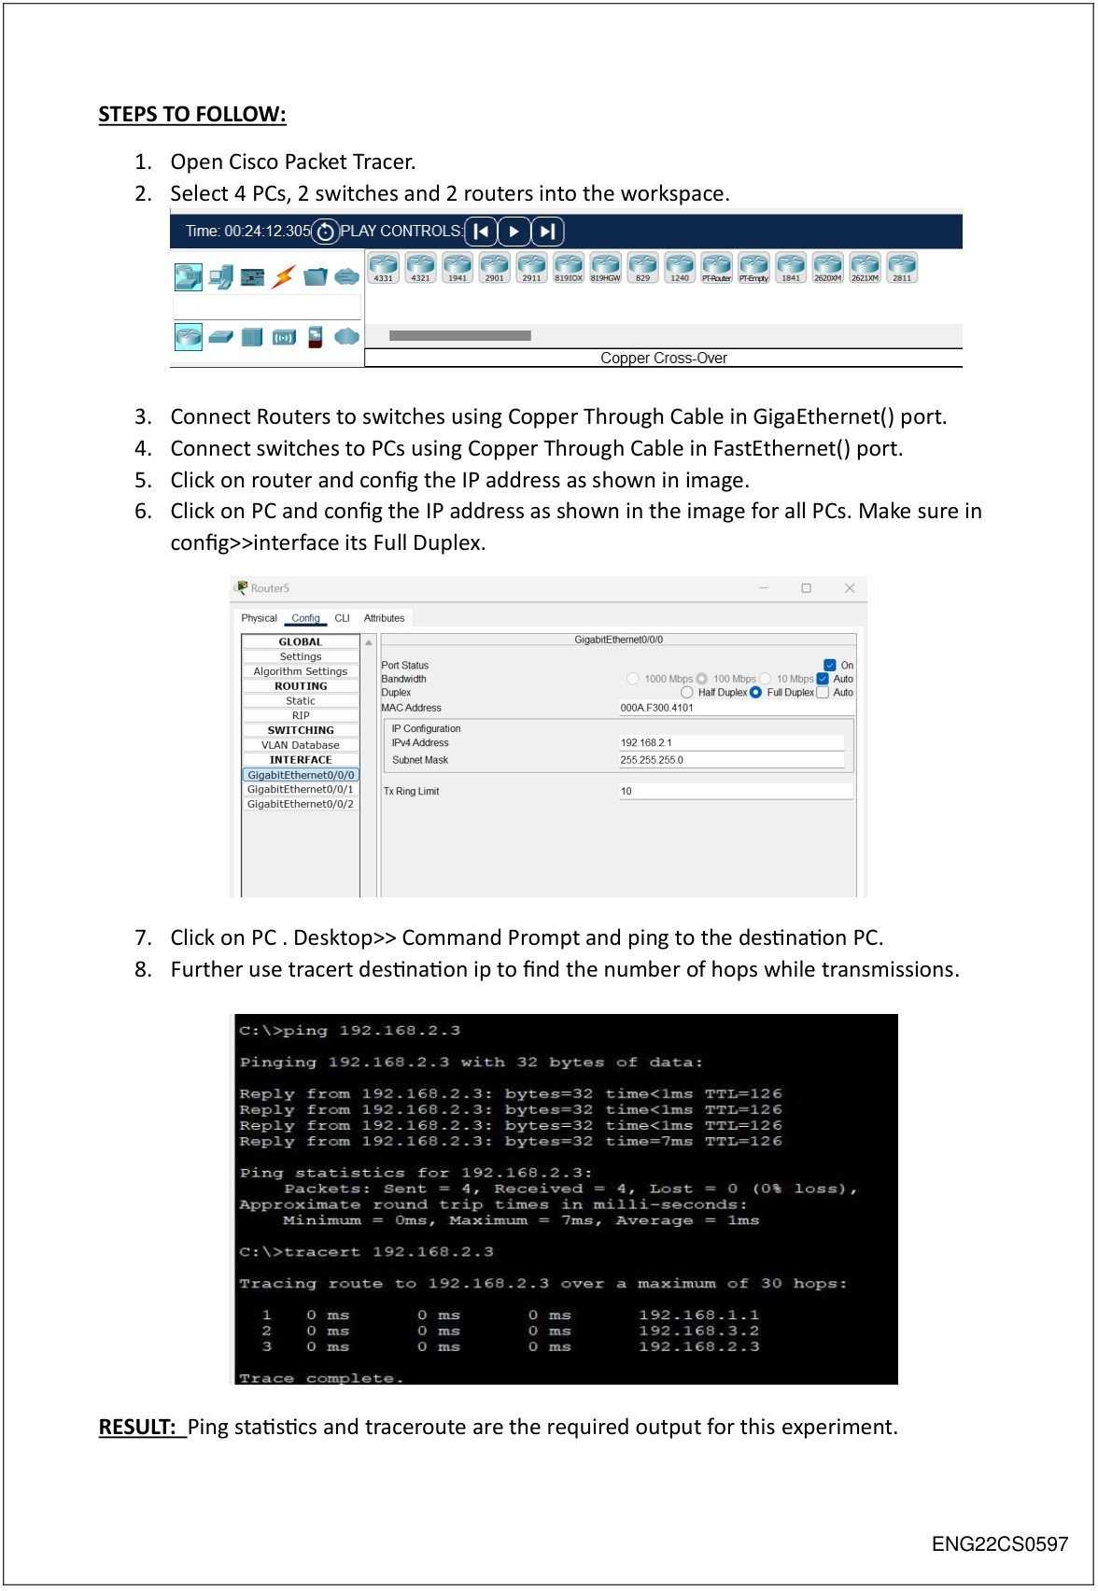

ENG22CS0169

Scanned with ACE Scanner

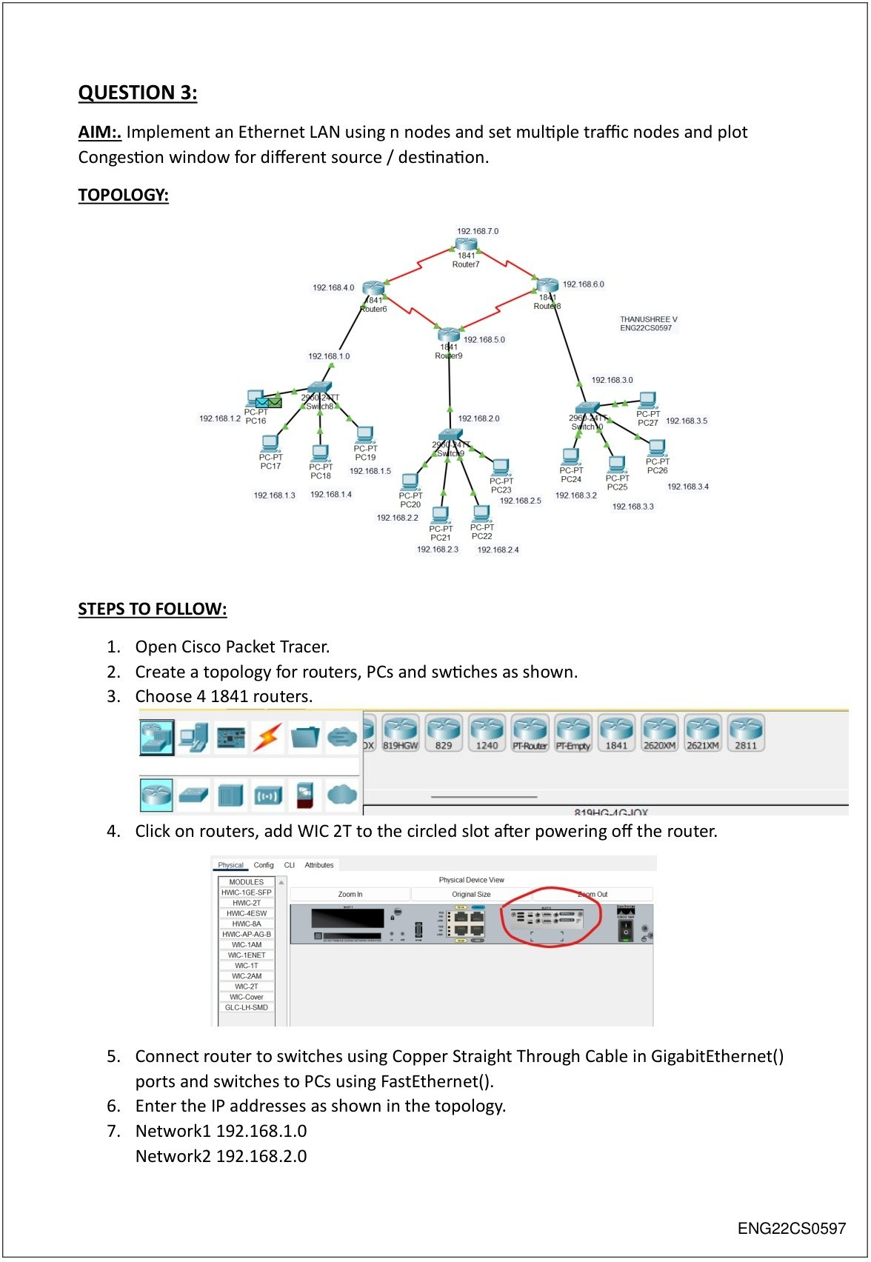

ENG22CS0169

SYED FUZAIL ENG22CS0476

Scanned with ACE Scanner

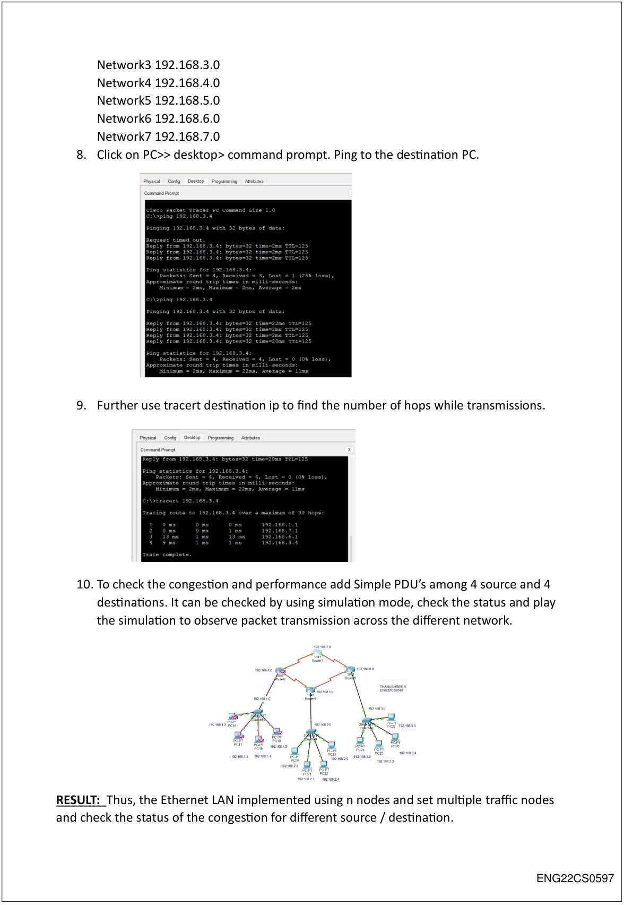

ENG22CS0169

SYED FUZAIL ENG22CS0476

Scanned with ACE Scanner

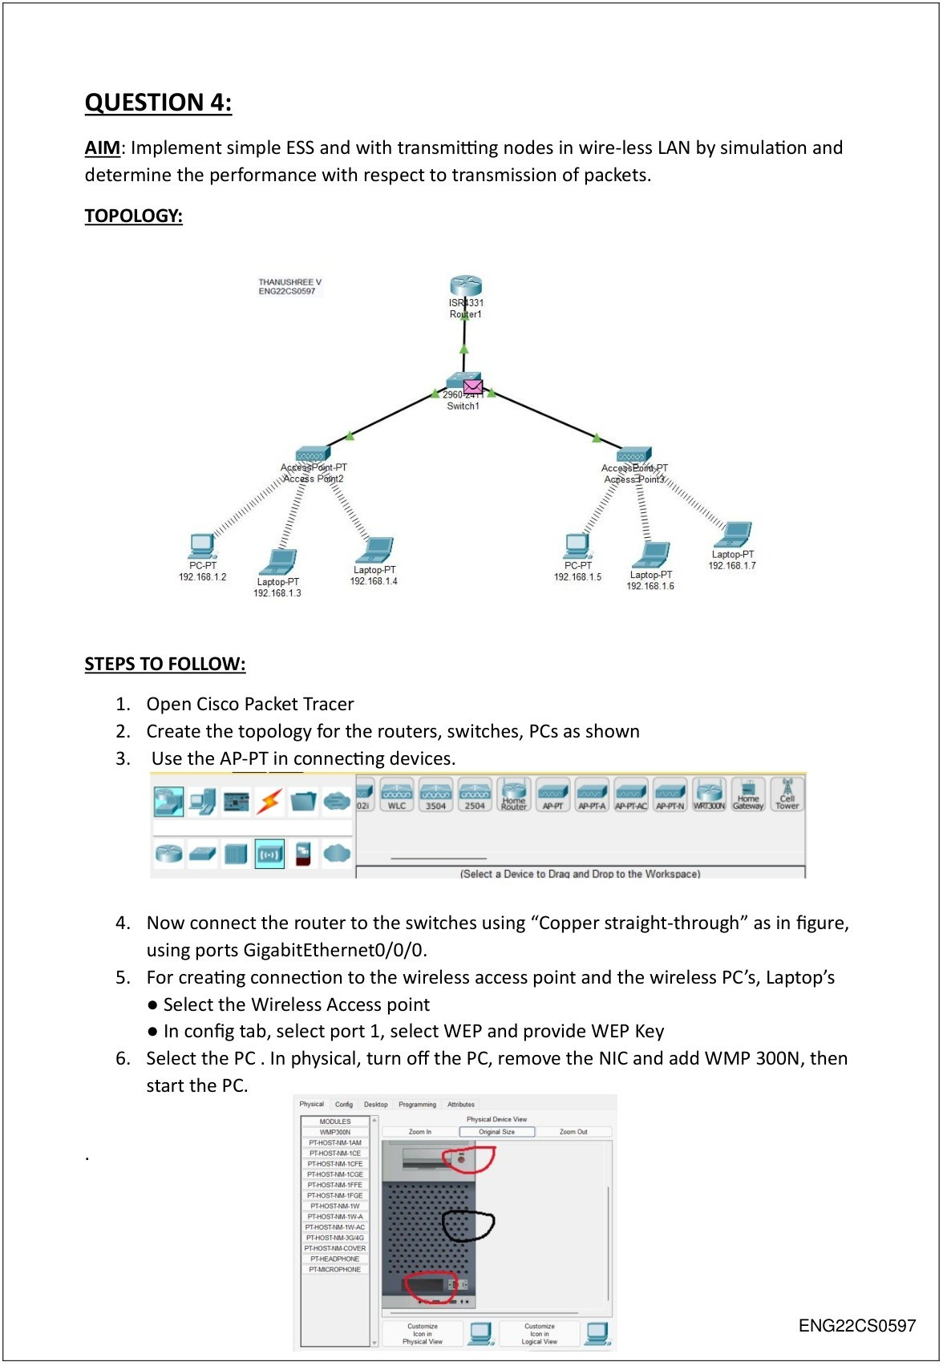

ENG22CS0169

SYED FUZAIL ENG22CS0476

Scanned with ACE Scanner

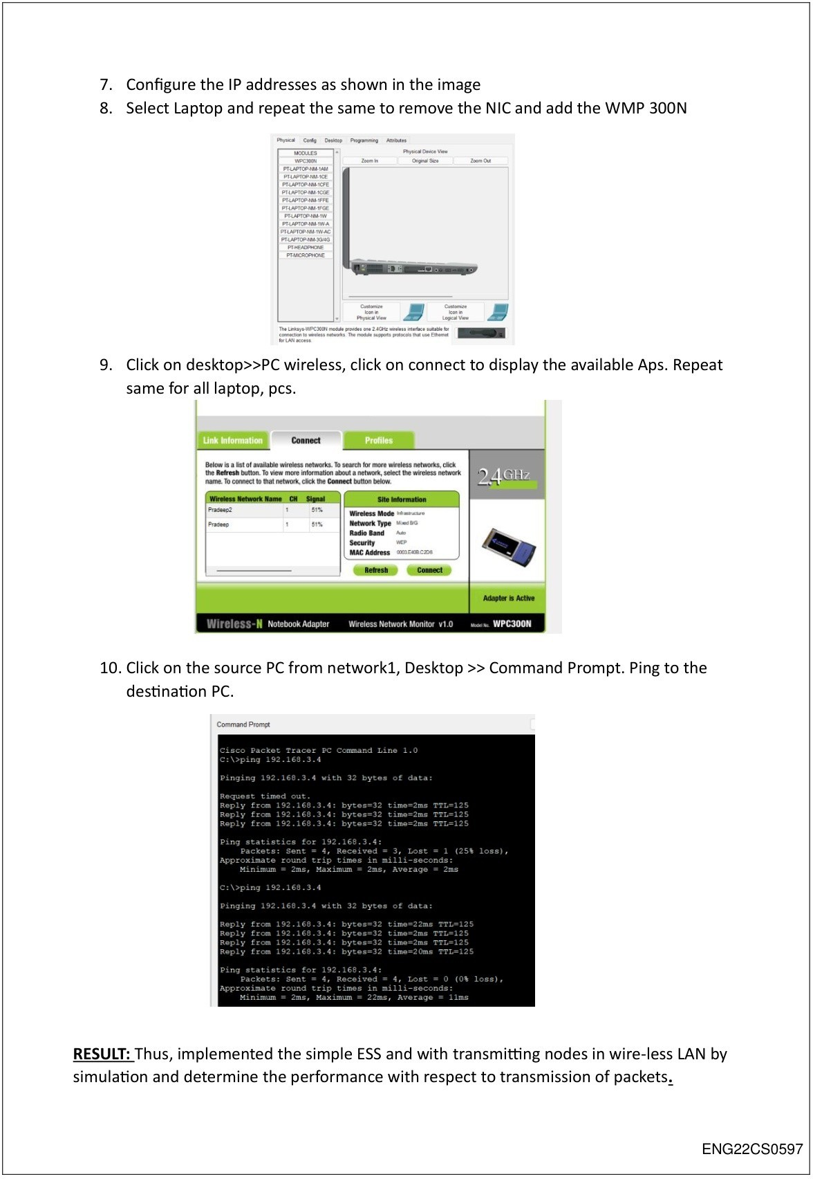

ENG22CS0169

Scanned with ACE Scanner

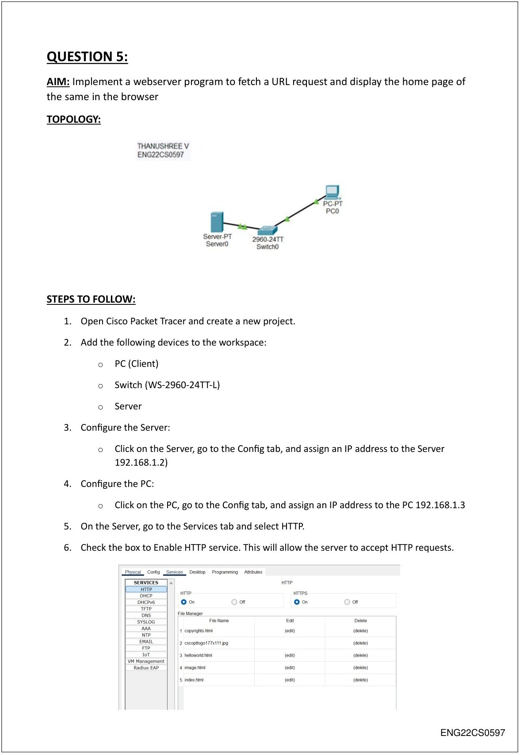

ENG22CS0169

SYED FUZAIL ENG22CS0476

Scanned with ACE Scanner

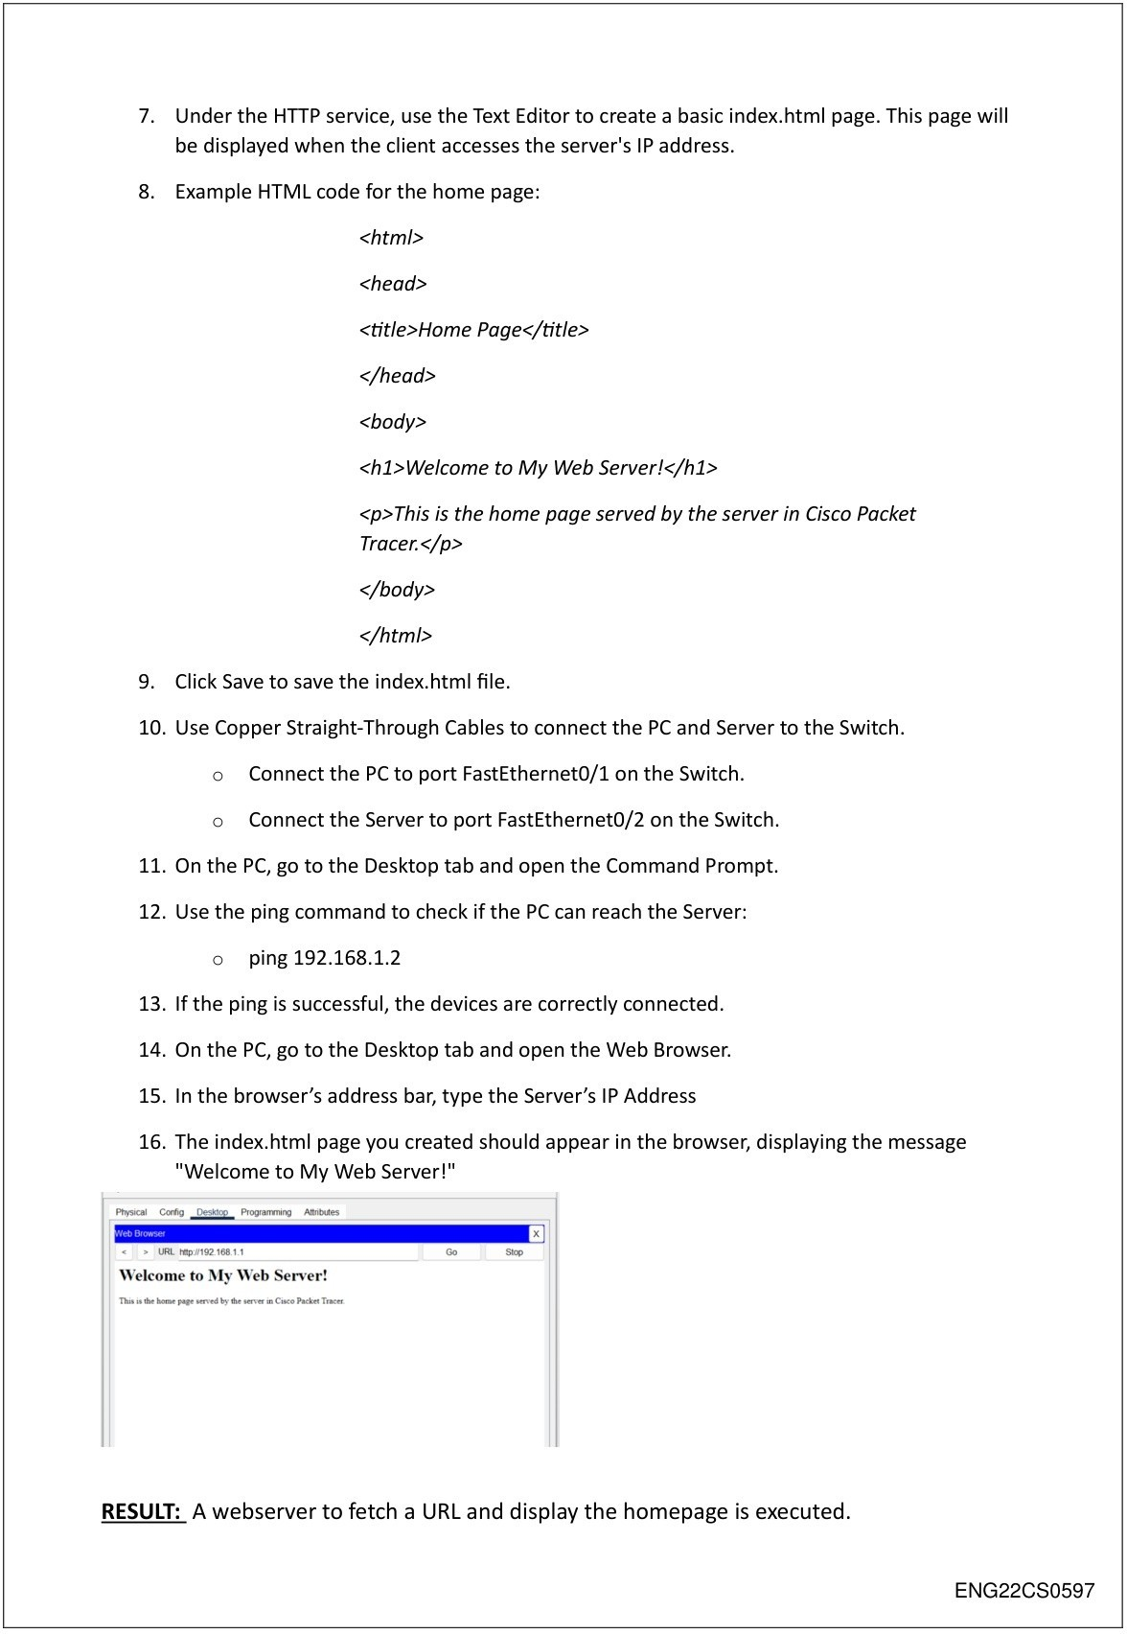

ENG22CS0169

Scanned with ACE Scanner

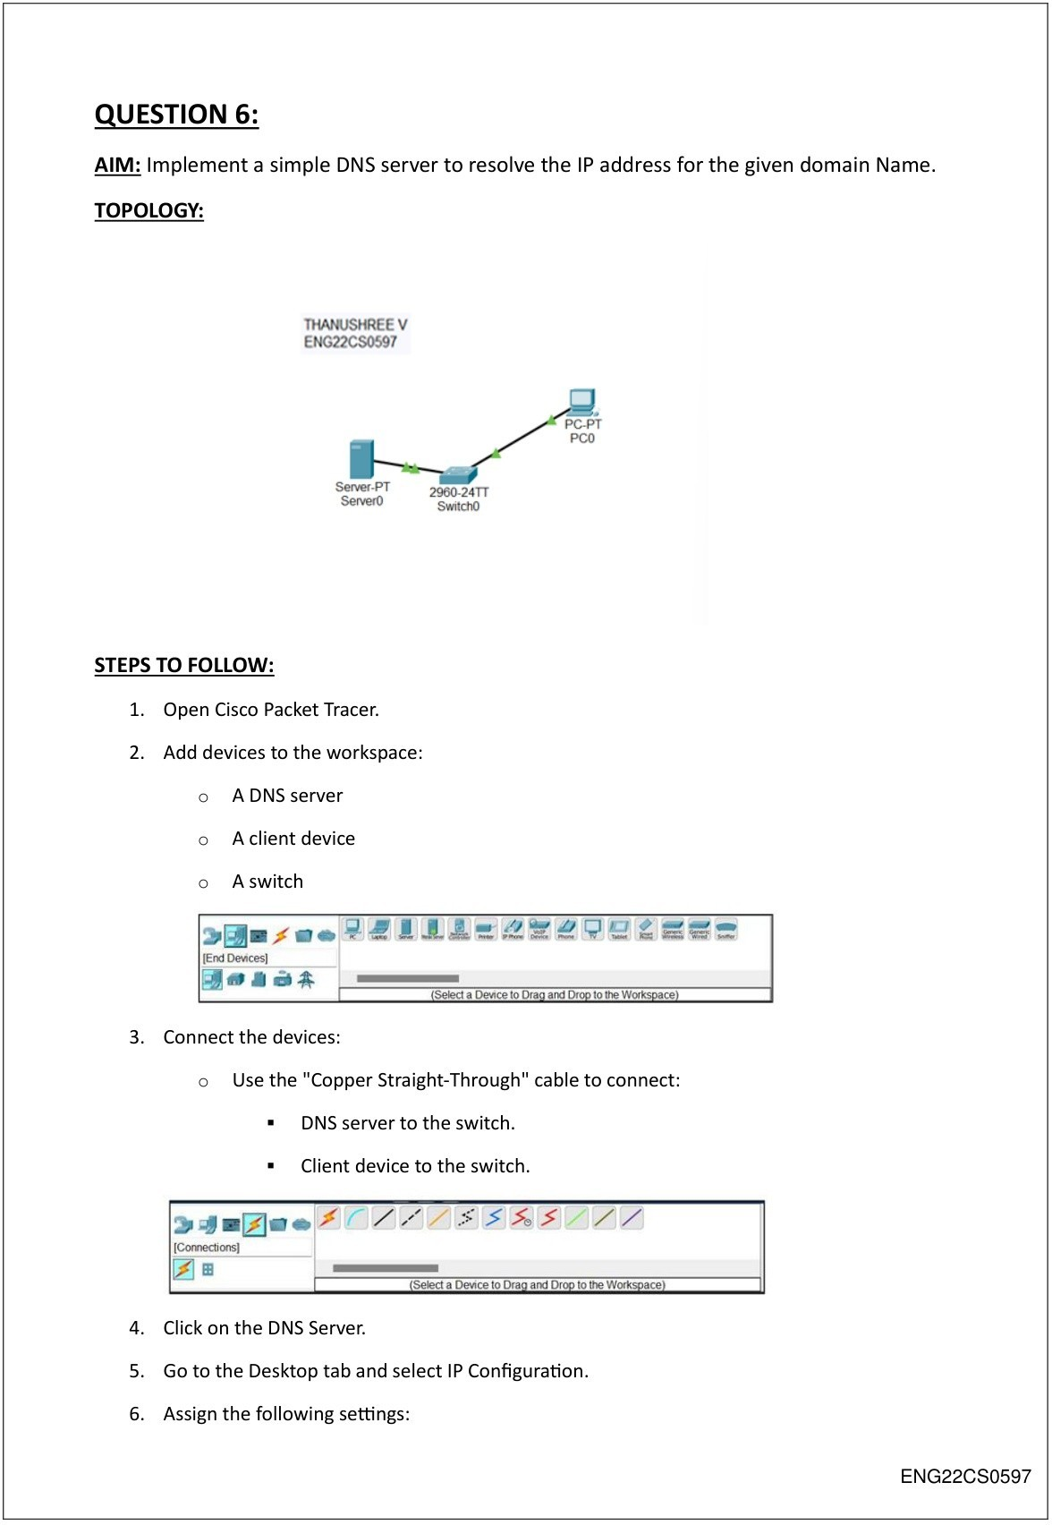

ENG22CS0169

SYED FUZAIL ENG22CS0476

Scanned with ACE Scanner

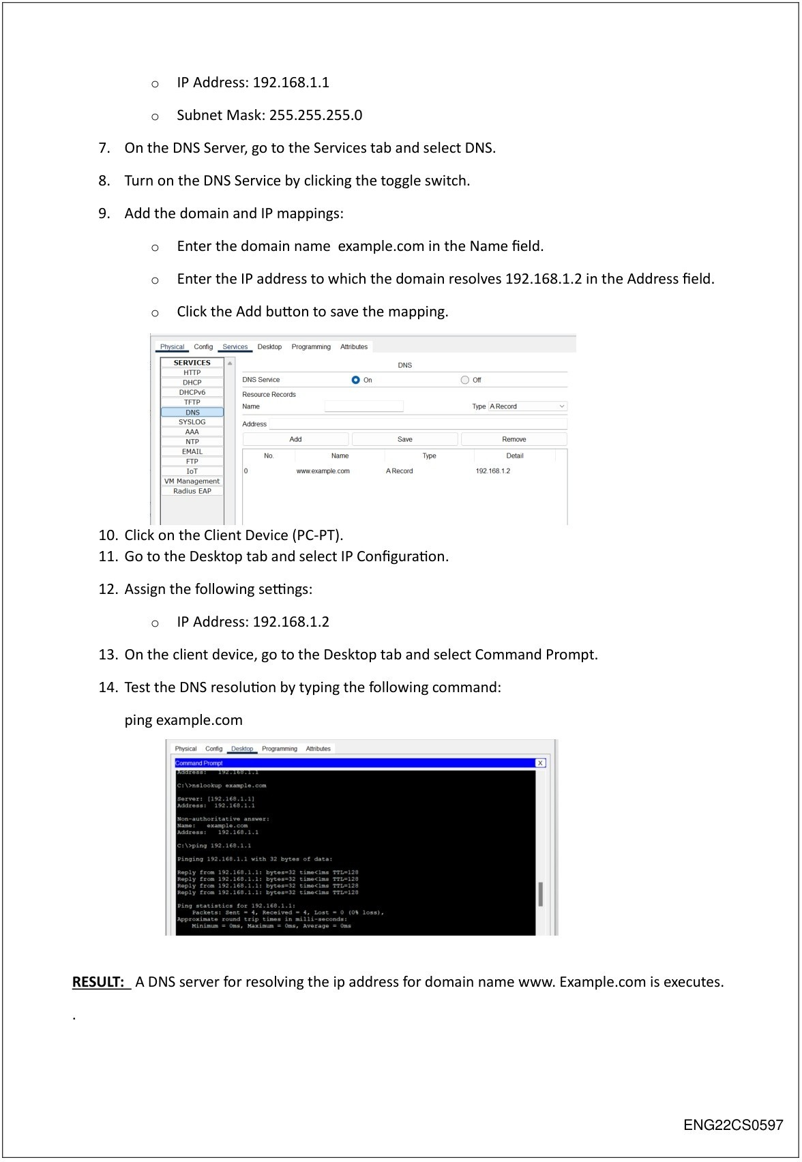

ENG22CS0169

Scanned with ACE Scanner